- Get the right IP of the device.
- You can use the default IP 10.10.10.254, if the speaker goes into setup mode, you should connect the speaker hot pot with the computer firstly.
- You also can use the IP assigned by the WIFI router. Your computer and speaker must be at the same WIFI router.
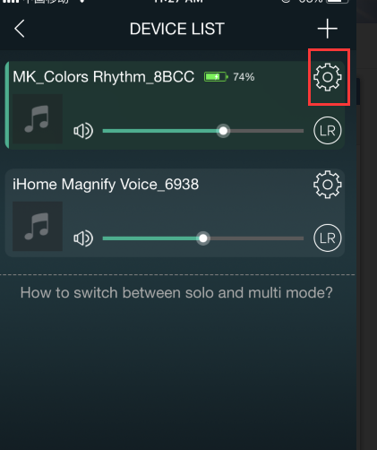
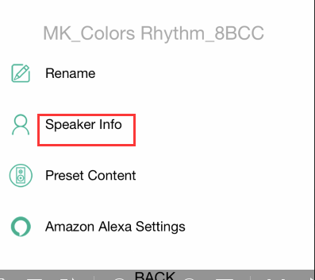

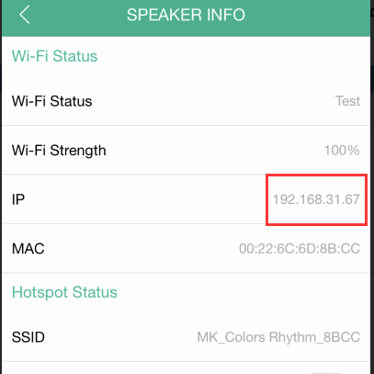

- Open the update tool. You can see the interface below.
Firstly, fill in the right IP address. Secondly, click connect. You will see the firmware version. Then you just need to choose the firmware by file path and click update. Then the progress bar will roll twice from 0% to 100% and then it's done.

